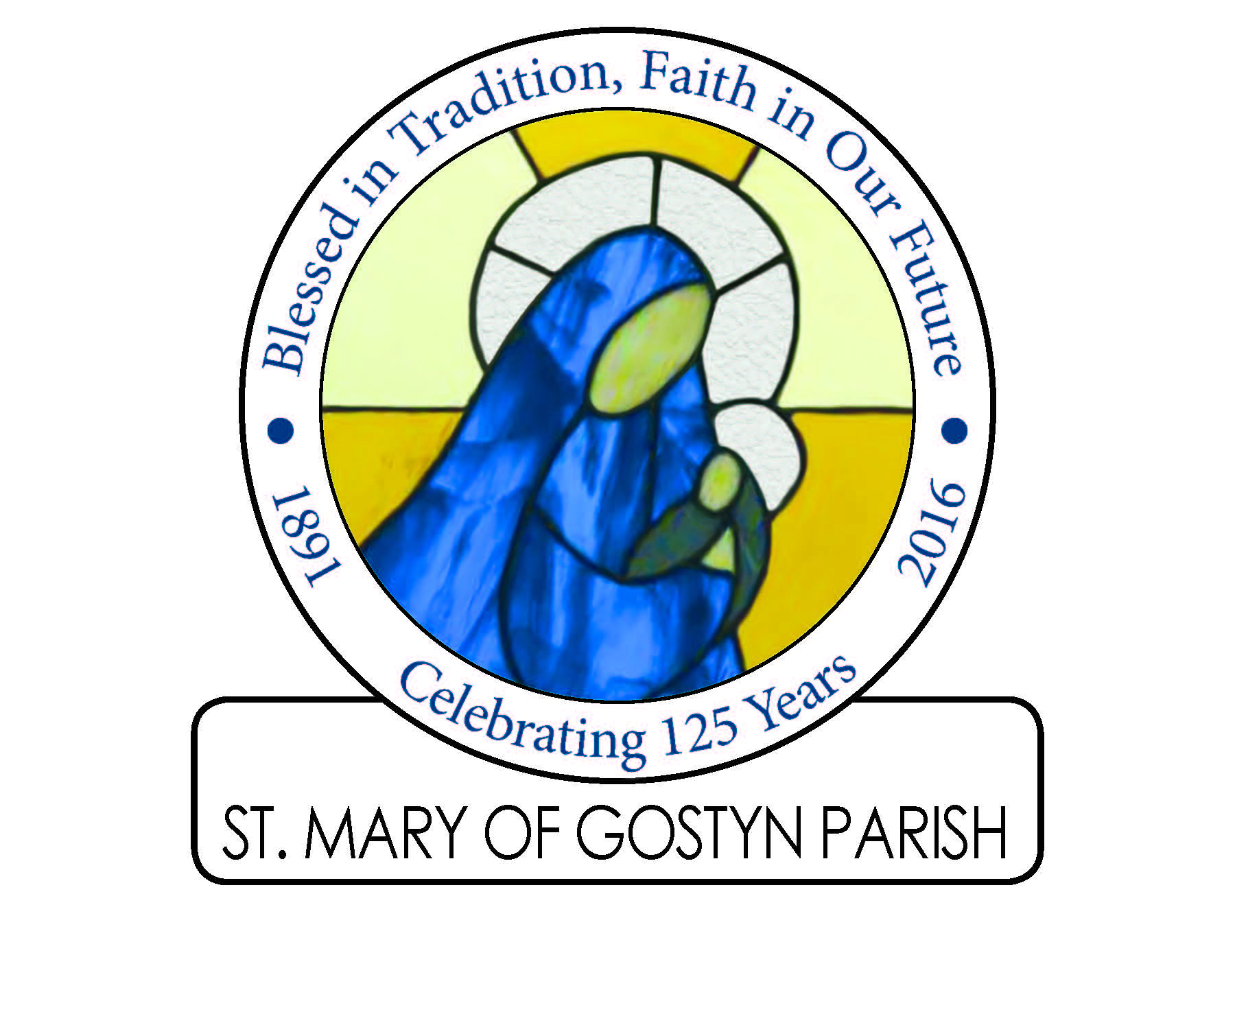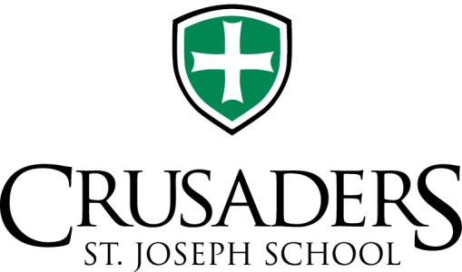
Show your School Spirit at the 1st Annual
Cross Town Basketball Alumni Holiday Tournament
St. Mary of Gostyn vs. St. Joseph’s

Friday, November 25, 2016
Time TBD, dependent on number of teams who register
Location: St. Mary of Gostyn Gym
440 Prairie Ave., Downers Grove

Registration fee of $350 for a team of 7
Includes tee shirts and officials.
Proceeds from concessions and fees will be given to the winning School!

We are looking for teams of 7 to represent your School. Male and Female teams are eligible to register. We are targeting Alum from the classes of 1990 through 2012 to play, all spectators are welcome. Teams can cross classes, but will be matched to relative same age groups. If you are interested in playing, please contact smgalumni@stmarygostyn.org by August 1st so that we can gauge the interest. Even if you do not have an entire team, but want to play, let us know.

